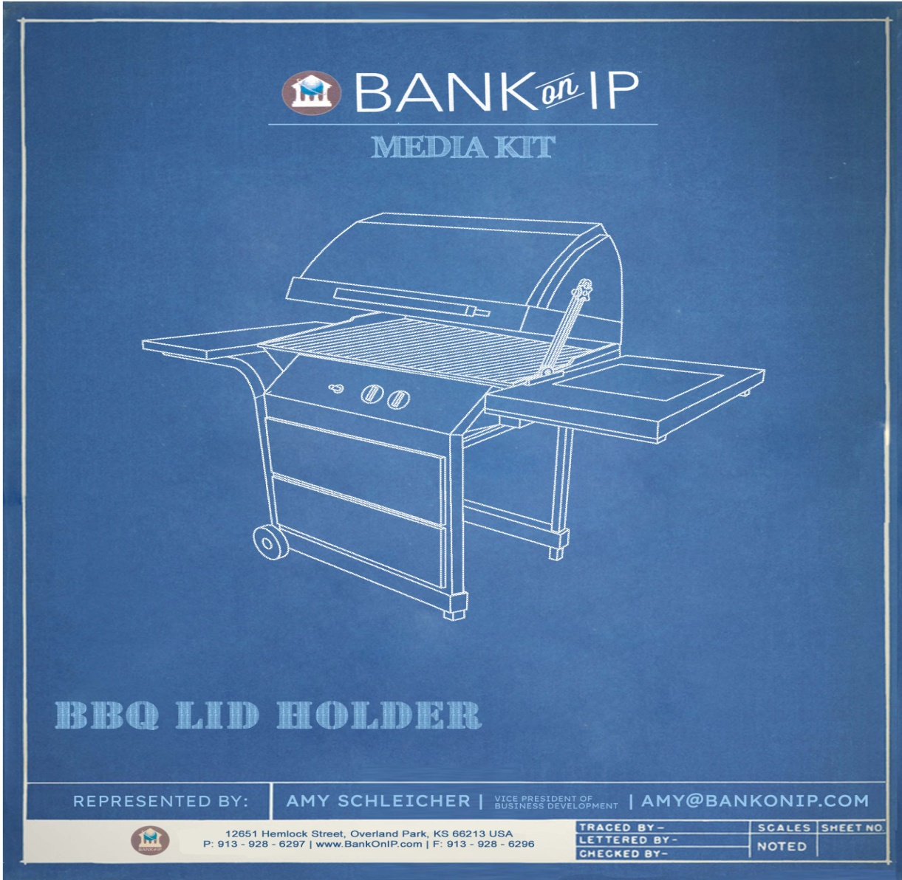

**BBQ LidHolder**

INTELLECTUAL PROPERTY AVAILABLE FOR   
LICENSING/ACQUISITION/INVESTMENT

U.S. Patent # 11,122,932 B2

TABLE OF CONTENTS

OVERVIEW 1

PRODUCT FEATURES & BENEFITS 2

COMPETITIVE LANDSCAPE 2

Comparable Established Products

Competitive Summary

PRODUCT DETAILS 4

Product Description

Product Specifications

Distribution Channels

FINANCIAL OUTLOOK 6

INTELLECTUAL PROPERTY 7

IP Information

Patent Owner Background

Patent

SUMMARY 10

Contact Information

Disclosure Statement

OVERVIEW

This prospectus will introduce the**BBQ LidHolder**, a newly patented technology available for licensing. In a 2022 survey it was found that 94 percent of Americans are pro-barbecue, with nearly one third saying they eat barbecue or barbecue-sauced foods in any given week (QSR magazine). According to PR Newswire 56% of Americans are passionate about grilling as a hobby. For most, the grilling atmosphere is their favorite part of the experience. In the 2022 state of the barbecue industry report by HPBA it was reported that 80 percent of all home owners and 70 percent of all households in the U.S. own at least one grill or smoker.

Why do we love barbecuing so much? Is it the social atmosphere – who doesn’t love a backyard barbecue – the taste, the increased nutritional value? It has been shown that grilling meat helps it to retain more nutrients compared to baking or frying. Plus, you also consume less fat because all the excess drips down thru the grill. Even veggies benefit more from grilling then from boiling or frying because it helps to preserve key nutrients. (Swimworldchelan.com 7 Best Reasons You Need a BBQ in Your Life) And there are so many options beyond just meat and veggies; pizza, quesadillas and even cake can be cooked on a BBQ.

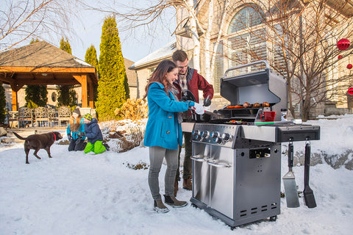Grilling has become a year-round lifestyle choice. Chilly temps don’t stop many consumers from grilling for the Super Bowl, Thanksgiving, Christmas, and New Years. Beyond the holidays, 49 percent barbecue for birthday parties, 24 percent for camping trips, 21 percent for vacation house parties, and 11% during tailgating activities for sporting events. (barbecuenews.com)

There is a wide range of grilling accessories available; from mats to special heat resistant gloves, cooking utensils (even utensils with built in lights) to special heat resistant grill lights, as well as in-grill rotisseries and cooking stones for pizzas. We use our grills for nearly any food we like, and we all know it takes both hands to safely work the grill. So how about an accessory to hold the lid of the grill for us hands free, safely and at the height we want rather than the options most grills limit us to: fully closed or open at a 90 degree angle?

The **BBQ LidHolder** is the answer. This innovative accessory allows the griller to choose the height of the lid, easily adjust the height as needed, and lock it in place to optimize cooking temperature, smokiness, and protect the food from the elements.

PRODUCT FEATURES & BENEFITS

Special features

* Easy to use to maintain desired cooking temperature
* Easy to control amount of smokiness
* Ability to maintain the lid at any position without interfering with the barbecue and grill cover
* Mountable on either side of the grill
* Easy to assemble
* Multi functional – can be used on standard grills, commercial grills, and fire pits
* May be constructed from thermal resistant plastic or stamped metal and metal alloys

COMPETITIVE LANDSCAPE

Currently available designed grills limit our ability to choose the position of a grill lid: fully closed or open to at or near a 90 degree angle. There are few options for holding the lid at a desired position, and even fewer are hands free and securable for safety.

We are a nation that loves grilling; the food, the socializing it affords, the health benefits, and want to be safe while grilling. The **BBQ LidHolder** can provide an easy and safe answer to this dilemma.

Comparable Established Products

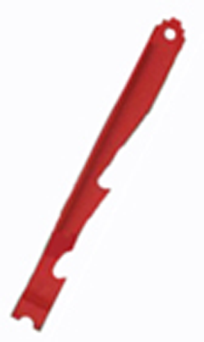

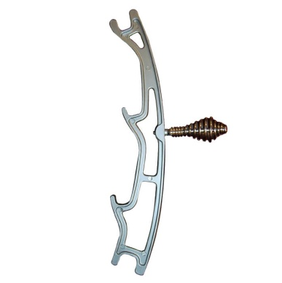

MCM Universal Grill Lid Holder Heaton 3 in 1 BBQ Tool

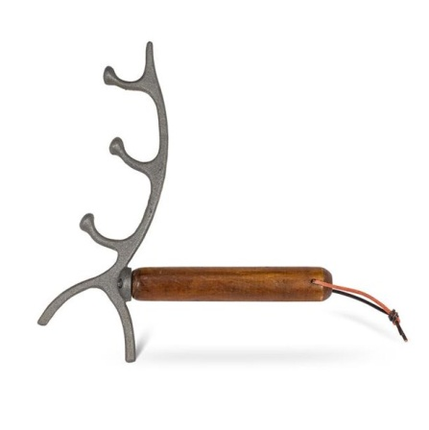

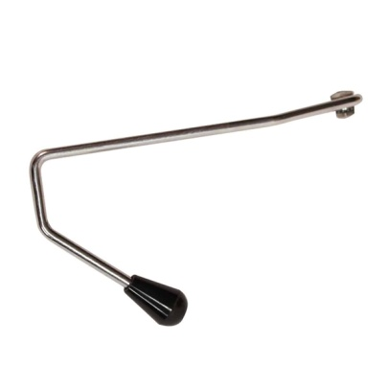

Abbot BBQ lid opener Broilmaster Adjustable Lid Stop

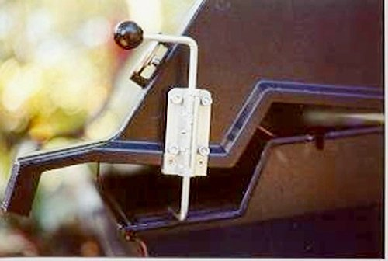

GrillShift Grill Lid Prop Handle

There are no products on the market that offer all of the features and advantages of the **BBQ LidHolder**.The first manufacturer to bring this product to market will profit greatly from its inherent uniqueness and cutting edge design. The **BBQ LidHolder** is truly in a class by itself.

Competitive Summary

|  |  |  |
| --- | --- | --- |
| **BBQ LidHolder**  Market Comparison | | |
| **FEATURE** | **BBQ LidHolder** | **COMPETITIVE PRODUCTS** |
| Easy to use to maintain desired cooking temperature | YES | SOME |
| Easy to control amount of smokiness | YES | SOME |
| Ability to maintain the lid at any position without interfering with the barbecue and grill cover | YES | NO |
| Mountable on either side of the grill | YES | NO |
| Easy to assemble | YES | SOME |
| Multi functional – can be use on standard grills, commercial grills, and fire pits | YES | NO |
| May be constructed from thermal resistant plastic or stamp metal and metal alloys | YES | NO |

PRODUCT DETAILS

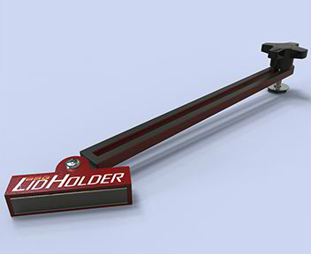Modern households love to grill and barbeque. Put simply, barbequing brings people together. Because of the popularity of grilling, people are continuously attempting to prepare better and more diverse meals on their barbecue grills. Over time, it has been discovered that certain foods cook differently depending on if the lid is open or closed. Keeping the lid closed may provide for more smoke which may add more flavor to the food. A closed lid may also provide a convection effect as heat will circulate in a closed grill rather than dissipating. Alternately, an open lid may provide completely different effects. The **BBQ LidHolder** provides the solution.

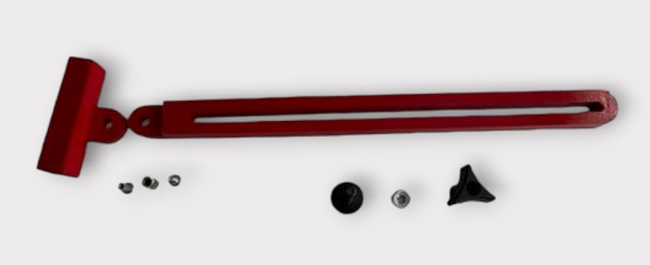The **BBQ LidHolder** consists of a slide rail with an adjustable fastener attached to the top of the slide rail and a shaped support base with an adjustable fastener attached to the bottom of the rail. The **BBQ LidHolder** is then attached to the lid of the grill by a bolt and the base to the grill tray by magnets or a hook and loop type adhesive and uses a hand tightening nut to hold the lid at the desired height. The **BBQ LidHolder** can be attached to either side of the grill for the chef’s convenience.

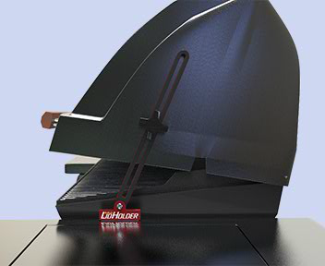Grillers know that variations in temperature can affect the speed the food cooks, the flavor, tenderness, and amount of smokiness. The **BBQ LidHolder** allows the griller to safely keep the lid opened to the optimum height for turning the items being grilled; adding your favorite sauce, adjusting the temperature the food is cooking at, and controlling the level of smoking. Thus creating the perfect texture and taste.

Most grills today consist of a lid that has two positions: fully closed or open to 90 degrees or more. With the **BBQ LidHolder** you choose the level of the lid and lock it in place or adjust as needed. The **BBQ LidHolder** removes the need to keep one hand on the lid when handling implements such as forks, tongs, bowls, and plates. The ability to lock the lid at a less than 90 degree angle allows the griller to monitor and adjust the level of heat the food is cooking at as well as providing protection from the elements.

Our love of barbequing year round has its challenges, but with the **BBQ LidHolder** no more raining or snowing on the cooking food. Who hasn’t had to deal with that gust of wind that can push the lid closed at the worst time?

The **BBQ LidHolder** can be used not only on standard grills, but commercial grills and fire pits.

Materials needed to produce the **BBQ LidHolder**:

* Heat resistant slid rail
* Adjustable fastener – hand tightened nut and

bolt assembly

* Shaped support base

Cost to produce the

BBQ LidHolder is estimated to be between $3 and $5 per unit.

* Rounded tab
* Footer
* Hook and loop fastening system or magnet
* Screw post and cap
* Corrugated nut
* Flat base bolt
* Heat resistant thermoplastic
* Metal or metal alloy

A working prototype of the **BBQ LidHolder** can be made available to demonstrate the design and functionality of the product.

Distribution Channel

A large distribution channel comprised of over 34,000 outlets exists to get the product to market. This would include 7,775 big box stores including Wal-Mart, Target, Sam’s and Costco, an estimated 8,637 specialty stores including Lowes, Home Depot, Menards and Ace Hardware, and over 18,000 general merchandise stores such as Dollar General. (Scraphero.com). The **BBQ LidHolder** can also be marketed directly to targeted buyers through promotion at trade shows, in trade magazines, direct mailing, catalogs, and the Internet.

FINANCIAL OUTLOOK

There are an estimated 131.2 million households in the U.S. that could utilize this unique product. An estimated 80 percent of American households own a grill or smoker. The subsequent financial projections are based on a conservative estimate that .1 percent of this market would purchase at least one **BBQ LidHolder** during its first year on the market. Assuming an average manufacturing cost of $4 and projected retail price of $25.00 per unit. An annual growth factor, based on a standard new product adoption curve, is assumed once the **BBQ LidHolder** gains market acceptance.

**Example Consumer Forecast:**

|  |  |  |  |
| --- | --- | --- | --- |
| Year | 2024 | 2025 | 2026 |
| Units Sold | 104,960 | 125,952 | 151,142 |
| Gross Sales | $2,624,000 | $3,148,800 | $3,778,550 |
| Cost of Goods | $419,840 | $503,808 | $604,568 |
| Gross Profit | $2,204,160 | $2,644,992 | $3,173,982 |

It is important to note that these projections should be considered as illustrative only of the tremendous market potential for this distinctive new product.It is clear that there is an enormous market for this product and that success in even a very small sector will generate huge returns.

INTELLECTUAL PROPERTY

Mr. Gary Ries holds United States Utility Patent No. 11,122,932 B2 filed on February 15, 2019, and issued on September 21, 2021. This patent for the **BBQ LidHolder** expires in 2039 commensurate with the filing date. This patent has 11 claims that protect the exclusive design and function of the **BBQ LidHolder.**

Patent Owner Background

Gary Ries, a resident of Las Vegas Nevada, loves barbecuing, get-togethers, and tailgating. He has worked outdoors most of his life and loves pretty much any outdoor sports and activities. One day while barbecuing it started to rain, so the lid had to be closed. This led to the thought of how much easier it would be if there was a way to adjust and hold the lid at a certain spot to control the temperature. And the **BBQ LidHolder** was born.

Patent

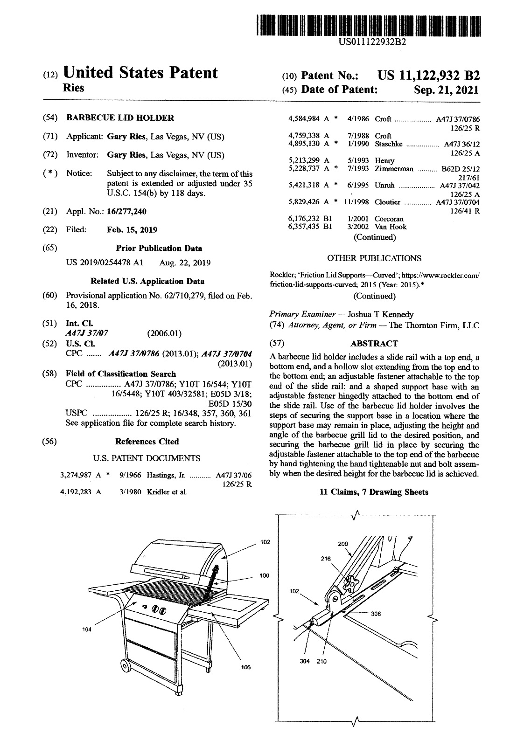

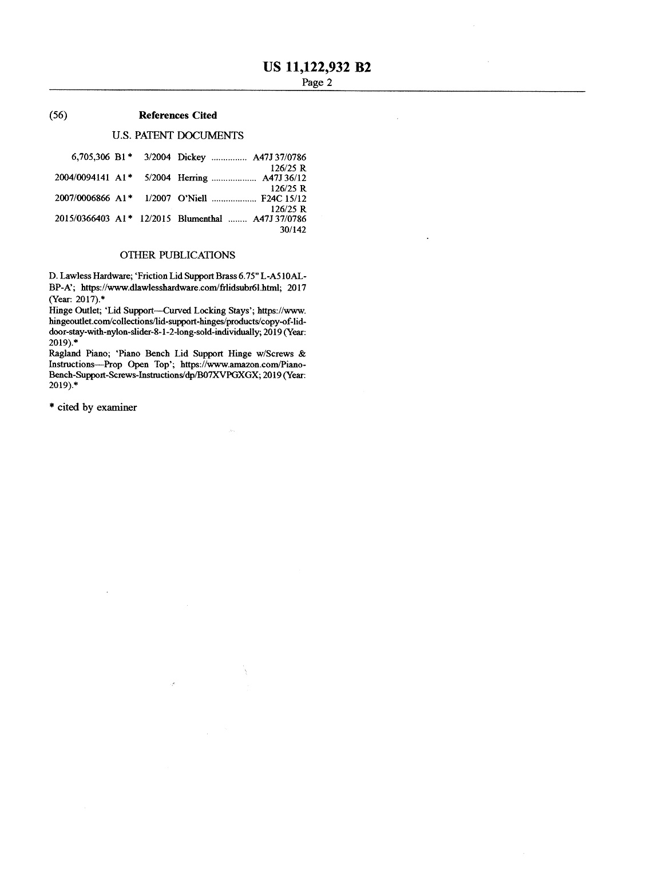

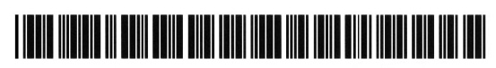SUMMARY

New Technology: **BBQ LidHolder**

Patent: **# 11,122,932 B2**

We are seeking a long-term arrangement with a company to manufacture, market, and/or distribute this new technology based on the acquisition of the intellectual property rights.

For additional information and potential terms to acquire this innovative technology contact:

AMY SCHLEICHER

Vice President of Business Development

BankOnIP

12651 Hemlock Street

Overland Park, KS 66213

Phone: 913.201.8025

Fax: 913.928.6296

Email: [Amy@BankOnIP.com](mailto:Amy@BankOnIP.com)

Disclosure Statement

BankOnIP (the “company”) has prepared the attached business prospectus (the “plan”) based upon its current understanding of the industry, expansion plans, markets, technology and other pertinent indicators. The plan contains information to provide prospective investors with a foundation on which to base meaningful discussion with management of the company. The projected financial information is management’s projection of possible future results and is dependent on many factors over which they are derived. Neither the company nor any of its representatives makes any express or implied representation or warranty as to the attainability of these projections or the accuracy, completeness or reasonableness of the assumptions. Neither the company nor any of its representatives makes any express or implied representation related to any past, current or future patent infringement claims the plan represents.

The company makes no express or implied representation or warranty as to the accuracy or completeness of the information contained in this plan including but not limited to patent infringement claims or other pertinent information. Statements in this plan are made as of the date hereof and are subject to revision at the sole discretion of the company’s management. Some of the revisions may be material. In all cases and notwithstanding the use of words such as “will” or “shall” or any discussion or characterization of future actions or events, this prospectus is intended to be an indication only of the company’s current intentions. The delivery of this plan shall not create, under any circumstance, any implication that there has been no change in the affairs of the company and other information contained herein since the date hereof.

The company makes no express or implied representation or warranty as to the attainability of the financial projections or the accuracy or completeness of the information herein or any other written or oral communication transmitted or made available. The projections of future performance are necessarily subject to a high degree of uncertainty and may vary materially from actual results. Only those representations and warranties that are made in a definitive agreement when and if executed, and subject to any limitations and restrictions as may be specified in such definitive agreement shall have any legal effect. The information provided herein does not constitute an offer to sell or the solicitation of an offer to buy any securities, assets, or properties, including without limitation, any products, processes, research, or intellectual property.



PROFESSIONALLY PREPARED   
AND REPRESENTED BY



12651 Hemlock Street, Overland Park, KS 66213 USA

P: 913.928.6297 | www.BankOnIP.com | F: 913.928.6296